Chaya Riwka Lipszyc, Velodroomstraat 5, Berchem, since 27.02.1930.

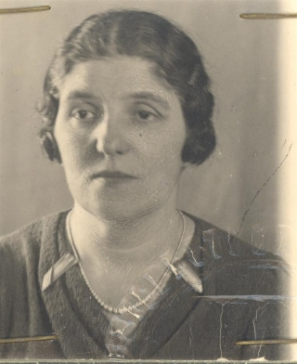

Chaya Riwka and her husband lived in their own house. Chaya Riwka was a housewife. She was born in Grajewo in Poland on 04.09.1890 and arrived in Belgium on 02.1930 as indicated in the Jodenregister, signed by her husband on 18.12.1940, since 1929 as indicated by the Joodse Vereniging in België, document from 27.03.1942). She had the Belgian nationality. Chaya was the sister of Leja Riwka Lipszyc. Chaya Riwka married Elias Chaim Rutzki, who was her cousin, he had the same grandparents on her fathers side. Anna and Siegfried were their children, born as Belgians in Antwerp. Elias Chaim Rutzki, his wife Chaja Riwka Lipszyc and their children Anna and Siegfried were arrested at home in the night of September 3rd on 4th 1943 during Aktion Iltis, the raid against Jewish inhabitants who had the Belgian nationality. Among the people arrested that night was also Anna’s husband : Nico Workum. All five family members were brought to the Dossin barracks after the raid. Here they were registered as person 106 (Nico), 454 (Elias Chaim), 455 (Chaja Riwka), 456 (Anna) and 457 (Siegfried) on the deportation list of transport XXII B (Belgians). This train left Mechelen on September 20th 1943 and arrived in Auschwitz-Birkenau on September 22nd 1943.The Rutzki family died after deportation, but there is no information on the date, place or circumstances of their death.
Elias Chaim Rutzki, Velodroomstraat 5, Berchem, since 19.03.1929.

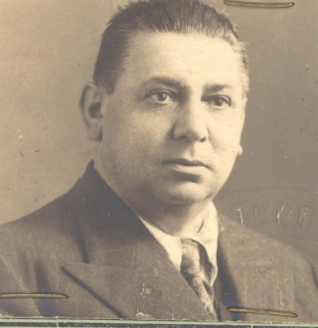

Elias Chaim and his wife lived in their own house. Elias Chaim was (‚diamantkoopman’, he buyed diamants).He was born in Chemagovitch in Russia on 22.07.1884 (Jodenregister, signed by Elias on 18.02.1940), or on 29.01.1884 (Joodse Vereniging in België, document from 27.03.1942) and lived since 1905 in Belgium (Jodenregister and Joodse Vereniging in België, document from 27.03.1942). He had the Belgian nationality. Elias Chaim married Chaya Riwka Lipszyc, who was his cousin, with the same grand parents on his mothers side. Anna and Siegfried were their children, born as Belgians in Antwerp. Elias Chaim Rutzki, his wife Chaja Rywka Lipszyc and their children Anna and Siegfried were arrested at home in the night of September 3rd on 4th 1943 during Aktion Iltis, the raid against Jewish inhabitants who had the Belgian nationality.

Leja Riwka Lipszyc, Velodroomstraat 5, Berchem, since 20.07.1934.

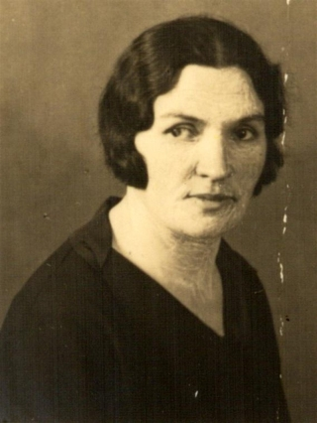

Leja Riwka was houswife. Leja Riwka was born in Grajewo in Poland on 04.03.1895. She arrived in Belgium at 11.1933 (Jodenregister, signed by Leja on 16.12.1940), since 1934 in Belgium (Joodse Vereniging in België, document from 27.03.1942). She had the Polish nationality. Leja was the sister of Chaya Riwka Lipszyc. She was a professional pianist. Leja Lipszyc presented herself voluntarily at the Dossin barracks on August 12th 1942. Like 12.000 other members of the Jewish community she had received an Arbeitseinsatzbefehl, a nazi convocation summoning her for forced labour in the east. Not obeying this letter, so the text said, would lead to severe consequences for their families. In the Dossin, Leja was registered as person 540 on the deportation list of transport III. This convoy left Mechelen on August 15th 1942 and arrived at Auschwitz-Birkenau on August 17th 1942. There is no information on the date, place or circumstances of her death.

Zelik Kagan, Velodroomstraat 5, Berchem.

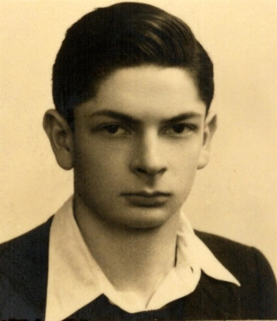

Zelik is the son of Leja Riwka Lipszyc and Salomon Kagan from whom she was divorsed. As profession is indicated on the transportlist: Handelsangestelte). Zelik was born in Grajewo, Poland on 07.04.1924. In 1934 he came to Belgium with his mother and he had the Polish nationality. In the summer of 1942 Leja’s son Zelik Kagan was deported by the nazis to the north of France together with 2.250 other Jewish men from Belgium as a forced labourer. In France Zelik Kagan worked for ‘Hermeke’ and ‘Leonhard Hanbuch und Sohne’, two subcontractors of Organisation Todt, the German institute responsible for the built of the Atlantic Wall. When the nazis realised they would not reach their Belgian deportation quota in 1942, they added the Organisation Todt workers to the Dossin deportation lists. On October 29th 1942 Zelik’s name was added to the list of transport XVII with number 262. This convoy left France on October 31st 1942 and arrived at Auschwitz-Birkenau on November 2nd 1942. Zelik Kagan died after deportation, but there is no information on the date, place or circumstances of his death.

Anna Rutzki, Lange Leemstraat 144, Antwerpen.

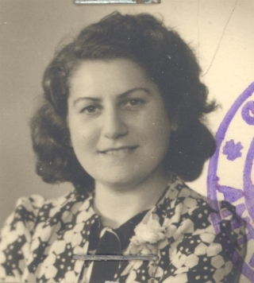

Anna is the daughter of Elias Chaim Rutzki and Chaya Riwka Lipszyc. She was born in Antwerp on 12.01.1920 with the Belgian nationality. Elias Chaim Rutzki, his wife Chaja Rywka Lipszyc and their children Anna and Siegfried were arrested at home in the night of September 3rd on 4th 1943 during Aktion Iltis, the raid against Jewish inhabitants who had the Belgian nationality. Among the people arrested that night was also Anna’s husband : Nico Workum. The two were married in 1943. Nico Workum was the president of the local branch of the Jewish Council of Belgium in Antwerp. All five family members were brought to the Dossin barracks after the raid.. This train left Mechelen on September 20th 1943 and arrived in Auschwitz-Birkenau on September 22nd 1943.The Rutzki family died after deportation, but there is no information on the date, place or circumstances of their death

Siegfried Rutzki, Velodroomstraat 5, Berchem.

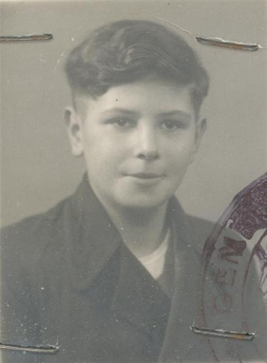

Siegfried is the son of Elias Chaim Rutzki and Chaya Riwka Lipszyc. He was born on 26.11.1930 in Antwerp and had the Belgian nationality. Elias Chaim Rutzki, his wife Chaja Riwka Lipszyc and their children Anna and Siegfried were arrested at home in the night of September 3rd on 4th 1943 during Aktion Iltis, the raid against Jewish inhabitants who had the Belgian nationality. All five family members were brought to the Dossin barracks after the raid. The train left Mechelen on September 20th 1943 and arrived in Auschwitz-Birkenau on September 22nd 1943.The Rutzki family died after deportation, but there is no information on the date, place or circumstances of their death.

Nico David Workum, Lange Leemstraat 144, Antwerpen.

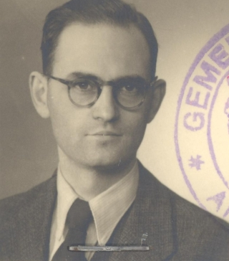

He was an engeneer. Nico was born in Amsterdam, Netherlands, on 07.10.1907. He was the son of Hartog Workum en Adèle Dusseldorp. His grandparents by mothers side were Nathan Dusseldorp and Rebecca Stynberg, by fathers side David Workum and Duifje De Jong. Nico married Anna Rutzki on 18.05.1943 (Jodenregister, getekend Wed. A. Workum-Dusseldorp op 20.12.1940). Nico stays in Belgium since 1923 . Elias Chaim Rutzki, his wife Chaja Riwka Lipszyc and their children Anna and Siegfried were arrested at home in the night of September 3rd on 4th 1943 during Aktion Iltis, the raid against Jewish inhabitants who had the Belgian nationality. Among the people arrested that night was also Anna’s husband : Nico Workum. The two were married in 1943. Nico Workum was the president of the local branch of the Jewish Council of Belgium in Antwerp. All five family members were brought to the Dossin barracks after the raid. Here they were registered as person 106 (Nico), 454 (Elias Chaim), 455 (Chaja Rywka), 456 (Anna) and 457 (Siegfried) on the deportation list of transport XXII B (Belgians). This train left Mechelen on September 20th 1943 and arrived in Auschwitz-Birkenau on September 22nd 1943.The Rutzki family died after deportation, but there is no information on the date, place or circumstances of their death.

